Presentation Skills Resources
Compiled by Kelly Preece, Researcher Development Manager
Contact me on: k.preece@exeter.ac.uk or @Preece_Kelly

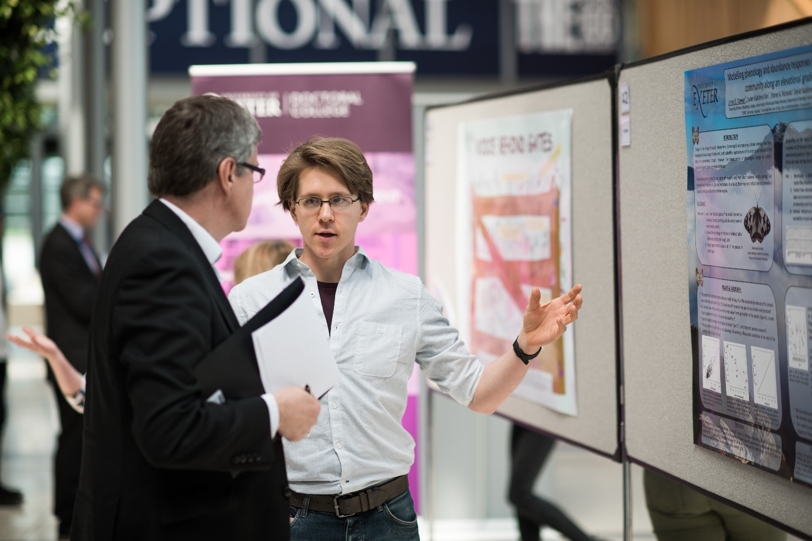

Researcher Development and Research Culture Team
Email: researcherdevelopment@exeter.ac.uk
Twitter: @ExeterDoctoral

Developing Your Presentation
Presenting - The Thesis Whisperer
The category archive on presenting on The Thesis Whisperer offers a wide range of advice, hints and tips for presenting your research - at conferences and in other formats.
Presenting Yourself and Your Research
This forms part of the GW4 Why Collaborate? resource, covering speaking plainly, as well as useful tips on storytelling when presenting.
Strategies for Effective Presentations - Monica Bulger
This slide deck from Monica Bulger introduces some really useful communication strategies for presentations.
5 Classic Presentation Mistakes - The Thesis Whisperer
This slide deck from The Thesis Whisperer introduces five classic presentation mistakes, and what to do about them.
How to Open and Close Presentations - Mark Powell
This YouTube video gives a really handy overview of the importance of how you open and close your presentation, and key strategies to make them more effective.
Presentations and the Art of Storytelling - Ondrej Cernotik
This blog post is aimed at scientific presenters, but is a useful introduction across the board to using storytelling in presentations.
The Secret Structure of Great Talks - Nancy Duarte
This TED Talk by Nancy Duarte examines the different structures of stories, and how we can use storytelling, and the power of the story, to being our presentations to life.
Flip Your Presentation Format - Patter
Here Pat Thomson proposes a 'flipped' structure for presentations, prioritising the conclusion and results over literature and theory.
A Conference Paper? It May Be Five Texts, Not One... - Patter
This blog post from Pat Thomson outlines the different 'papers' you need to write when developing you conference paper - the abstract, the paper, the slides, the script/notes and the handout.

Elevator Pitches
Stop waffling Five steps to a successful research 'Elevator Pitch' - The Supervisor Whisperers
This post on The Thesis Whisperer sister-blog has some really pertinent advice on developing an elevator pitch, that can be applied to presentations as a whole.
The Elevator Pitch - Physics as Exeter
The Physics department have taken the idea of the Elevator Pitch literally, and created a series of YouTube videos where PGRs and ECRs explain their research - in the time it take for the lift to get to the top of the Physics building!

Nerves and Body Language
Getting Your Body Language in To Shape - VOX Coaching
These tips from VOX Coaching are quick routes in to thinking about your body language when presenting.
A Handy Guide to Managing the Jitters - VOX Coaching
These tips from VOX Coaching are quick routes in to managing nerves when presenting.
11 Tips For Calming Your Nerves Before a Big Presentation - Business Insider
This article for Business Insider contains some really useful advice for managing and calming your nerves.

Public Speaking
How to Speak So That People Want to Listen - Julian Treasure
This TED Talk by Julian Treasure talks about speaking and acoustics more generally, and given a useful introduction to using your voice effectively including explanations of pitch, timbre and so on.
5 Things Every Presenter Needs to Know About People - Susan Weinschenk
This YouTube video thinks about your audience, and what you need to know about them to give an effective presentation.
TED Talks The Official TED Guide to Public Speaking - Chris Anderson
This book, available through google and the University library, outlines some of the strategies used to prepare TED speakers.
How To Be Yourself - Dr. Caitlin Kight
This blog post by Dr. Caitlin Kight, Academic Developer discusses and offers advice being yourself when public speaking, and the ways in which this is impacted by being a minority.

Visual Aids
Dr. Joanna Garner on Effective Presentation Slides - Research in Action Podcast
Often when we are designing our presentation slides, we are designing them as aids to the presenter rather than the audience. This podcast from Research in Action includes strategies, based on research, to make your presentation slides more effective.
Resonate: Present Visual Stories That Transform Audience - Nancy Duarte
This ebook from Nancy Duarte delves in to storytelling in presentations, and how to use your visual aids to do this effectively.
How to Avoid Death by PowerPoint - David Phillips
This TED talk from David Phillips discusses how we use PowerPoint badly, and simple principles for making the most of your visual aids.
10 tips on how to make slides that communicate your idea - TED
This article has some top tips from TED experts on better slides.
6 dos and don’ts for next-level slides, from a TED presentation expert
Before you deliver your next speech, pitch or address, learn how to create exceptional slides by following these rules (with real before-and-afters).

Making Effective Slides - Anitra Nottingham
This slide deck outlines, in lots of detail, the principles of designing effective slides to accompany your presentation.
Choosing Images of Slideshows - Pat Thomson
This blog post from Pat Thomson contains some principles of how to choose images for your slides that add to the meaning and understanding.

Dealing With Questions
Responding to Questions Effectively - University of Leicester
This resource from the University of Leicester introduces some simple strategies from responding to questions - including difficult ones.
Don't Be a Conference Troll A Guide to Asking Good Questions - The Guardian Higher Education Network
It is important to think about how you ask questions at conferences, as well as how to respond to them. This article from The Guardian Higher Education Network outlines how to support other researchers by asking good questions after their presentations.

